**In-class Exercise**

Write SQL queries for the following: (submit the query and a screenshot of the results)

1. Display the maximum total_payment of invoices. (5 Points)

“select max(payment_total) from invoices;”



2. List the number of VENDORS in each state and the number should be greater than 5. (20 points)

“select vendor_state, count(vendor_state) from vendors group by vendor_state having count(vendor_state) > 5;”



3. List the vendor_ID, vendor NAME for those who do not have any invoice. (15 Points)

“select vendor_id, vendor_name from vendors where vendors.vendor_id not in (select invoices.vendor_id from vendors, invoices where invoices.vendor_id = vendors.vendor_id);”

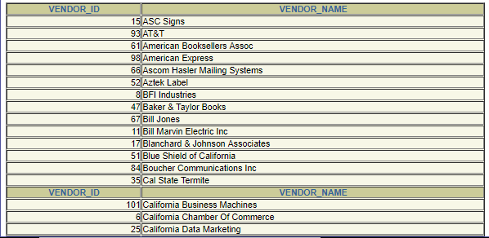

4. List the vendor_ID, vendor NAME and the number of invoices for each vendor. List only those that have more than 2 invoices. (20 Points)

5. List the invoice_id for the highest invoice value . [Use sub-query. Do not hard-code the value] (20 points)

“select invoice_id from invoices

where invoice_total in (select max(invoice_total) from invoices);”



6. Write a SQL query to create a sequence MYSEQ, that starts from 100 and increment by 5. Display the next value in the sequence. (Submit two queries. One for creating the sequence and the other for displaying the next value.) (20 points)

“create sequence MYSEQ

increment by 5 start with 100;”



“select MYSEQ.nextval from dual;”

